Questions 1, 2, 6, and 7

**One:**

Using a little bit of algebra, prove that (4.2) is equivalent to (4.3). In other words, the logistic function representation and logit representation for the logistic regression model are equivalent.

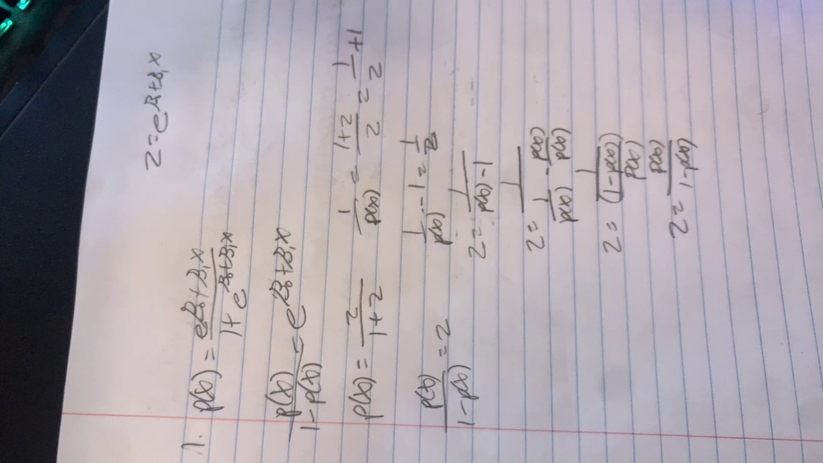

**Two:**

It was stated in the text that classifying an observation to the class for which (4.12) is largest is equivalent to classifying an observation to the class for which (4.13) is largest. Prove that this is the case. In other words, under the assumption that the observations in the kth class are drawn from a N (μk, σ2) distribution, the Bayes’ classifier assigns an observation to the class for which the discriminant function is maximized.

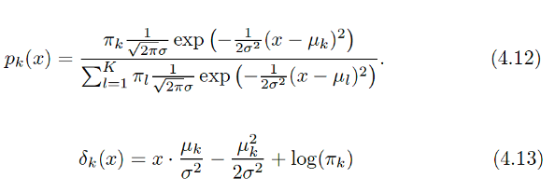



**Six:**

Suppose we collect data for a group of students in a statistics classwith variables X1 = hours studied, X2 = undergrad GPA, and Y = receive an A. We fit a logistic regression and produce estimated coefficient, ˆβ0 = −6, ˆβ1 = 0.05, ˆβ2 = 1.

(a) Estimate the probability that a student who studies for 40 h and has an undergrad GPA of 3.5 gets an A in the class.

(b) How many hours would the student in part (a) need to study to have a 50 % chance of getting an A in the class?



**Seven:**

Suppose that we wish to predict whether a given stock will issue a dividend this year (“Yes” or “No”) based on X, last year’s percent profit. We examine a large number of companies and discover that the mean value of X for companies that issued a dividend was ̄X = 10,  
while the mean for those that didn’t was ̄X = 0. In addition, the variance of X for these two sets of companies was ˆσ2 = 36. Finally, 80 % of companies issued dividends. Assuming that X follows a normal distribution, predict the probability that a company will issue a dividend this year given that its percentage profit was X = 4 last year.

Hint: Recall that the density function for a normal random variable is f (x) = 1√2πσ2 e−(x−μ)2/2σ2. You will need to use Bayes’ theorem.

**Extra:**



